Task 1
Creating a New User Account (musicfan) on Linux

Objective: Open the Ubuntu terminal and use administrative commands (useradd or adduser) to create a new user account named musicfan, configure its password securely, and verify the user creation.
1. Step-by-Step Execution Procedure:
1.Root/Sudo Terminal Access:Step 1: Open Terminal.
- Log into your Ubuntu Server terminal with administrative privileges (sudo/root access).
2.Run adduser Command:Step 2: Create the User Account.
- Execute the interactive adduser command to create the user and automatically generate its home directory:
3.Password Configuration:Step 3: Set User Password.
- When prompted, enter a secure password for the musicfan user (e.g., MusicFan@2026), re-type it to confirm, and press Enter.
4.Check /etc/passwd:Step 4: Verify User Creation.
- Verify that the user was successfully added to the system user database:
2. Terminal Command Execution & Output Logs:

ubuntuuser@ubuntu-server:~$ sudo adduser musicfan
[sudo] password for ubuntuuser:
Adding user `musicfan' ...
Adding new group `musicfan' (1001) ...
Adding new user `musicfan' (1001) with directory `/home/musicfan' ...
Changing the password for musicfan
New password:
Retype new password:
passwd: password updated successfully
Changing the user information for musicfan
Enter the new value, or press ENTER for the default
Full Name []: Music Fan
Room Number []:
Work Phone []:
Home Phone []:
Other []:
Is the information correct? [Y/n] Y

ubuntuuser@ubuntu-server:~$ grep musicfan /etc/passwd
musicfan:x:1001:1001:Music Fan,,,:/home/musicfan:/bin/bash

3. Task Summary Reference Table:

Action Performed | Command Executed | Result / Output Status
User Creation | sudo adduser musicfan | Created user profile with home directory /home/musicfan
Password Setup | passwd (Interactive prompt) | Password successfully updated and verified
Database Check | grep musicfan /etc/passwd | Confirms user entry with UID 1001 and Bash shell

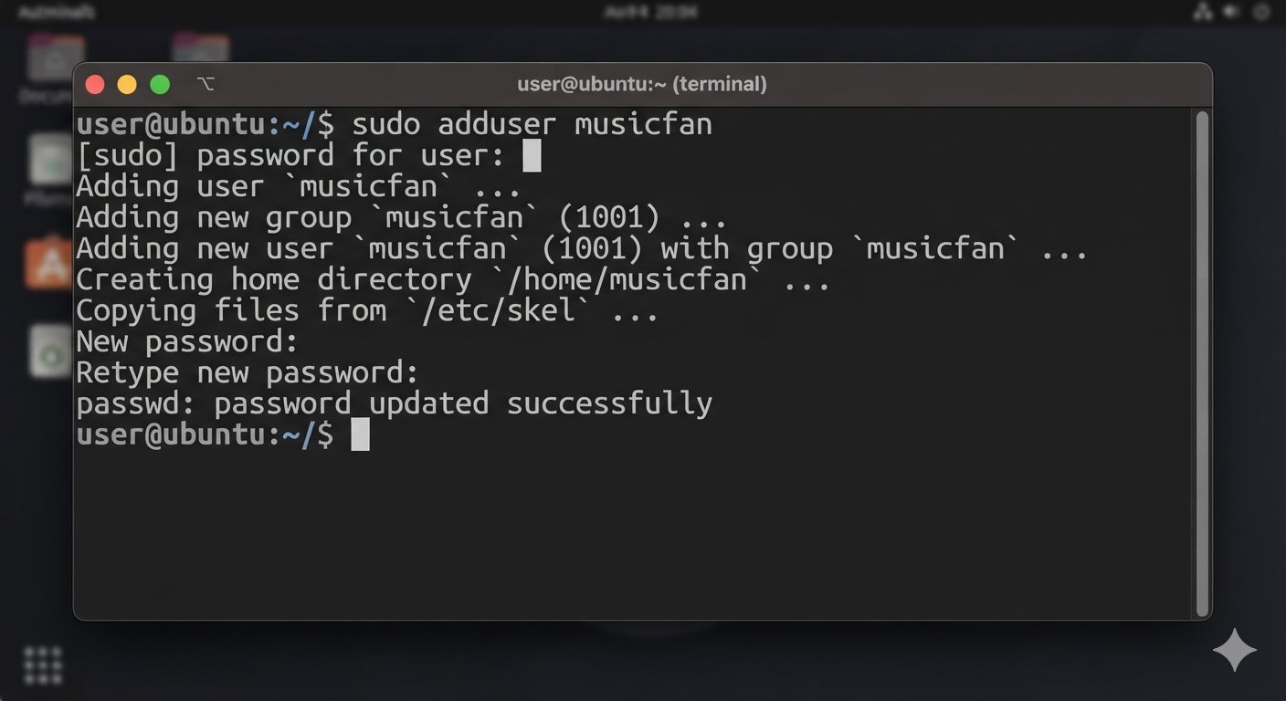

Task 2
Managing Directory Ownership and Permissions (chown & chmod)

Objective: Create a target directory named SpotifyDownloads, assign user ownership to musicfan using the chown command, and grant read and write permissions using the chmod command via the Linux terminal.
1. Step-by-Step Execution Procedure:
1.Create SpotifyDownloads folder:Step 1: Create the Target Directory.
- Open your terminal and create a new directory named SpotifyDownloads:
2.Run chown Command:Step 2: Change Directory Ownership.
- Transfer ownership of the directory to the musicfan user:
3.Run chmod Command:Step 3: Assign Read and Write Permissions.
- Grant read, write, and execute permissions to the owner (and appropriate permissions for others):
- Alternative specific write permission command:
4.Run ls -ld Verification:Step 4: Verify Ownership and Permissions.
- Verify the permissions and owner of the folder:
2. Terminal Command Execution & Output Logs:

ubuntuuser@ubuntu-server:~$ mkdir SpotifyDownloads

ubuntuuser@ubuntu-server:~$ sudo chown -R musicfan:musicfan SpotifyDownloads

ubuntuuser@ubuntu-server:~$ sudo chmod -R 755 SpotifyDownloads

ubuntuuser@ubuntu-server:~$ ls -ld SpotifyDownloads
drwxr-xr-x 2 musicfan musicfan 4096 Oct 14 13:40 SpotifyDownloads

3. Command Breakdown Reference Table:

Command Used | Purpose / Action | Explanation
mkdir SpotifyDownloads | Directory creation | Creates the local folder
sudo chown -R musicfan:musicfan | Ownership transfer | Makes musicfan the owner user and group for the directory and its contents
sudo chmod -R 755 | Permission modification | Grants Read/Write/Execute to Owner (7), and Read/Execute to Group/Others (5)
ls -ld | Verification | Displays directory permissions and ownership details

Task 3:
Creating a New User Account (flipkartuser) and Adding to 'Shoppers' Group in Active Directory

Objective: Use Windows Server Active Directory tools (Active Directory Users and Computers) to create a new domain user account named flipkartuser, set its credentials, and assign it as a member of a security group named Shoppers.
1. Step-by-Step Execution Procedure:
1.Launch ADUC Management Console:Step 1: Open Active Directory Users and Computers.
- Open Server Manager on your Windows Server.

- Click on Tools in the top-right corner and select Active Directory Users and Computers (ADUC).
2.Create AD Group:Step 2: Create the 'Shoppers' Security Group.
- Expand your domain node (e.g., foodiefans.local) and select the target OU or Users container.

- Right-click in the empty pane $→$ Hover over New $→$ Click Group.

- Enter Group name: Shoppers, leave Group scope as Global and Group type as Security, then click OK.
3.Create New AD User:Step 3: Create the 'flipkartuser' Account.
- Right-click inside the container/OU $→$ Hover over New $→$ Click User.

- Enter First/Full name: flipkartuser and User logon name: flipkartuser, then click Next.

- Enter a secure password (e.g., Flipkart@123), uncheck "User must change password at next logon", and click Finish.
4.Configure Group Membership:Step 4: Add User to the 'Shoppers' Group.
- Double-click on the newly created flipkartuser account to open its properties.

- Navigate to the Member Of tab and click Add....

- Type Shoppers, click Check Names to resolve it, and click OK, then Apply.
2. Verification Command / GUI Summary Logs:
PowerShell Verification Command (Alternative Management Method):

# Create Group
New-ADGroup -Name "Shoppers" -GroupScope Global -GroupCategory Security

# Create User
New-ADUser -Name "flipkartuser" -SamAccountName "flipkartuser" -UserPrincipalName "flipkartuser@foodiefans.local" -AccountPassword (ConvertTo-SecureString "Flipkart@123" -AsPlainText -Force) -Enabled $true

# Add User to Group
Add-ADGroupMember -Identity "Shoppers" -Members "flipkartuser"

# Verify Group Membership
Get-ADGroupMember -Identity "Shoppers"

Component Created | Name / Identifier | Target Container | Configuration Status
Security Group | Shoppers | Domain Users / OU | Created successfully
User Account | flipkartuser | Active Directory Domain | Password configured & Enabled
Group Membership | Member of Shoppers | User Properties $→$ Member Of | Successfully assigned
Task 4
Applying Group Policy to Restrict USB Storage Access for 'flipkartuser'

Objective: Configure a Group Policy Object (GPO) in Windows Server Group Policy Management Editor to target and block USB storage device access for the specific user (flipkartuser), and document its security enhancement benefit.
1. Step-by-Step Execution Procedure:
1.Launch GPMC:Step 1: Open Group Policy Management Console.
- Open Server Manager $→$ Click Tools $→$ Select Group Policy Management.
2.Configure GPO:Step 2: Create or Edit a Group Policy Object.
- Expand your domain (foodiefans.local), right-click and select Create a GPO in this domain, and Link it here..., name it Restrict_USB_Policy.

- Right-click the newly created policy and select Edit to open the Group Policy Management Editor.
3.Policy Path:Step 3: Navigate to Removable Storage Access Settings.
- In the editor console tree, navigate to:

Computer Configuration (or User Configuration for user-specific targeting) $→$ Policies $→$ Administrative Templates $→$ System $→$ Removable Storage Access.
4.Configure USB Restriction:Step 4: Enable USB Deny Access Policy.
- Look for the setting: Removable Disks: Deny execute access, Removable Disks: Deny read access, and Removable Disks: Deny write access.

- Double-click each, set them to Enabled, and click Apply and OK.
2. Security Explanation (One-Line Summary):
Security Improvement Benefit: Restricting USB storage access prevents unauthorized data exfiltration and blocks the introduction of malware or malicious payloads via external flash drives.
3. Task Summary Reference Table:

Policy Parameter | Configuration Path / Setting | Action Applied
GPO Name | Restrict_USB_Policy | Linked to Active Directory Domain / OU
Policy Category | Administrative Templates $→$ System $→$ Removable Storage Access | Controls hardware mount/access permissions
Enforcement | Deny Read / Write / Execute | Blocked for unauthorized users (flipkartuser)

Task 5
Role-Based Access Control (RBAC) & User Permissions in Food Delivery Platforms (Zomato / Swiggy)

Objective: Identify three distinct user account roles within a food delivery platform ecosystem (Zomato / Swiggy) and define specific operational permissions or restrictions for each account type to maintain platform security and integrity.
1. User Accounts and Permission Breakdown Table:

# | User Account Role | Specific Permission (Should Have) | Restriction / Access Denied (Should NOT Have)
1 | Customer | Order Placement & Tracking: Can browse menus, place food orders, and track real-time delivery status. | Admin & Merchant Access: Cannot modify restaurant menus, pricing, or access other user/delivery agent data.
2 | Restaurant Owner / Partner | Menu & Order Management: Can update food item availability, accept/reject incoming orders, and view daily earnings. | Platform Governance: Cannot modify platform-wide commission rates or access other independent restaurants' financial records.
3 | Delivery Partner (Driver) | Order Fulfillment Interface: Can accept delivery assignments, view customer drop-off locations, and update delivery status. | System Control: Cannot alter customer billing profiles, refund amounts, or restaurant catalog settings.

2. Enterprise Security Architecture Explanation:
Implementing strict Role-Based Access Control (RBAC) ensures that users can only access information and execute actions strictly necessary for their specific operational role, preventing unauthorized data breaches, financial fraud, and unauthorized backend tampering.

